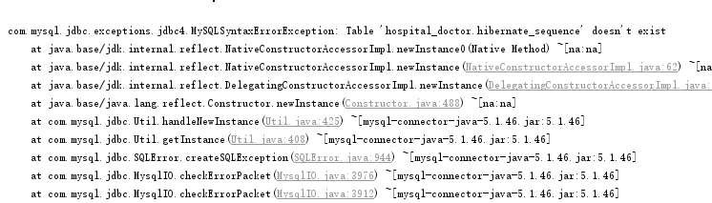
com.mysql.jdbc.exceptions.jdbc4.MySQLSyntaxErrorException:
Table 'hospital_doctor.hibernate_sequence' doesn't exist

解决方案
原因mysql id为自增列，要加@GeneratedValue(strategy=GenerationType.IDENTITY)
